Lecture 12
CHEMISTRY OF NUCLEIC ACIDS II
INTRODUCTION
The two major classes of nucleic acids are Deoxyribonucleic acid (DNA) and Ribonucleic acid (RNA). The DNA is the carrier of genetic information while the RNA is an intermediate in the expression of genetic information and other diverse role. DNA is found in the nucleus with small amounts in mitochondria and chloroplasts. RNA is found throughout the cell.
The only significant variation in chemical structure of nucleic acids is the type of base in each nucleotide position. The bases are not involved in formation of the nucleotide backbone but serve as a distinctive side chain.

Structure of DNA
Deoxyribonucleic acid (DNA) is an example of polynucleotide and it is one of the two types of nucleic acids that made up the genetic materials.
DNA exists as a double stranded molecule in eukaryotes but single stranded DNA is common among the prokaryotes. The two helical polynucleotide chains usually coil around a common axis. DNA must undergo series of folding and super-folding to enable it fit into the little space available inside the nucleus of cells. This continuous folding finally give rise to a genetic material called chromosomes. Segment of a strand that contains sequence of nucleotides capable of producing a functional protein is referred to as a gene. The four nucleotide units present in DNA are deoxyadenylate, deoxythymidylate, deoxyguanylate and deoxycytidylate.

A unique characteristic of naturally occurring DNA molecules is their very long chain of nucleotides. A DNA molecule must comprise many nucleotides; this enables it to store sufficient genetic information necessary for even the simplest organism. For example, the E.coli genome is a single DNA molecule consisting of two chains of 4.6 million nucleotides. The human genome (complete genetic information of an organism) comprises of about 3 billion nucleotides.
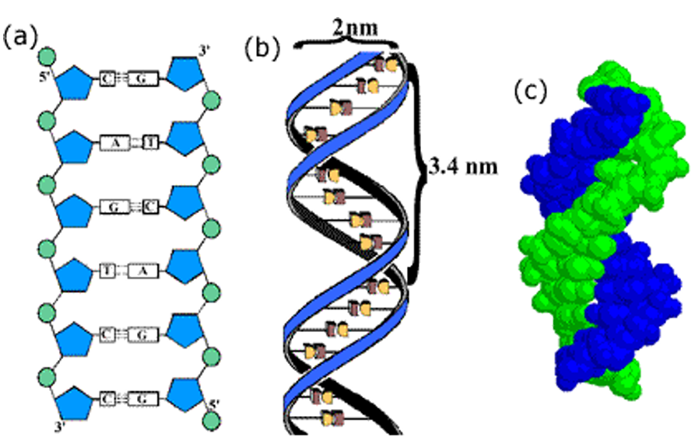
Figure 1: (a) Stacking of two Chains (b) Double Stranded Structure of DNA (c) Beads Representation of Double Stranded DNA.
Ribonucleic acid is also a polynucleotide like DNA but it exist as a single stranded molecule. It is usually produced from the DNA in eukaryotes but it serves as the main genetic material in some viruses, especially the retroviruses such as HIV. The sequence of nucleotides in RNA is determined by the sequence of DNA present in the cell.
There are some differences between RNA and DNA:
i. The sugar component of DNA is deoxyribose but in RNA we have ribose sugar
ii. The nucleotides are also different by just one; in place of thymine monophosphate in DNA, uridine monophosphate is present in RNA.
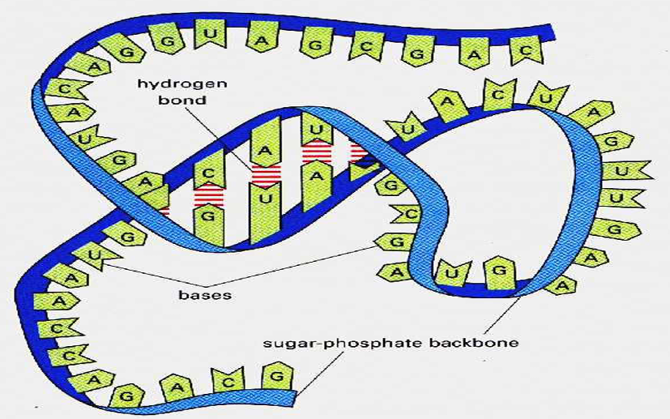

Figure 2: The Structure of RNA, Molecule.

Description of Duplication and RNA Synthesis in Nucleic Acid
(i) Replication (ii) Transcription (iii) Translation (iv) DNA Denaturation and Renaturation
i. Replication: This is also known as duplication, it is the process by which a replica or identical copy of DNA is made from the parent copy. This process occurs whenever a cell is preparing to divide. This process must take place so that the new cell will also contain the same genetic information present in the old cell. This is how the genetic information is preserved and passed from one generation to the next.
ii. Transcription: This is the process by which the genetic messages contained in the DNA molecule are read and copied correctly to produce ribonucleic acid (RNA). This process occurs whenever the cell or tissue requires a particular protein to carry out a biochemical process; the protein required can be an enzyme, receptor or other forms of proteins.
iii. Translation: This is the process by which the genetic messages carried by RNA are decoded and used to build proteins (enzymes, receptors, hormones etc).
iv. DNA denaturation and renaturation: The process of separating the complementary strands of duplex DNA is called denaturation. The double stranded structure of DNA can be separated into two component strands in solution by:
- increasing the temperature,
- decreasing the salt concentration
- And by extreme pH (strongly acidic or strongly basic solution).
Because of the base stacking and the hydrogen bonding between the bases, the double stranded DNA molecule exhibits properties of a rigid rod and in solution; it is a viscous material that loses its viscosity upon denaturation as well as its biological properties.

The complete separation of DNA strands occur over a temperature range (5⁰ range). The heating disrupts the hydrogen bonds between base pairs thereby causes the strands to separate. This process is also called melting of DNA. The melting temperature ™ of DNA molecule depends on the pH and ionic strength of the solvent. Purine and pyrimidine base composition also affect the melting temperature of DNA; the greater the content of G and C, the higher the melting temperature and vice-versa. There are 3 bonds between G and C while there are 2 bonds between A and T. The melting temperature ™ is defined as the temperature at which half of the helical structure is lost.
DNA solution absorbs maximally at a wavelength of 260mm, the absorbance increases as the double helix is separated into single strands (denaturation).
This principle is also known as hypochronism.
Renaturation is the opposite of denaturation, it is the process of reassociation of separated strands of DNA or any two strands of DNA that are complementary in base pairing. This process takes place only when the appropriate physiologic temperature and salt concentration are achieved. Re-naturation is also called hybridization.

Importance of some Synthetic Nucleotides
Synthetic nucleotides are used in chemotherapy of cancer and viral infections. Modified synthetic analog of purines, pyrimidines and nucleotides have useful applications in clinical medicine. These compounds are used to treat cancer because they can prevent DNA synthesis due to their toxicity to the enzymes involved in DNA synthesis.
Some of the synthetic nucleotides are also used to manage AIDS patients, because they are toxic to an important enzyme required for DNA synthesis in the virus. For example Azidothymidine (AZT) is a potent inhibitor of reverse transcriptase in HIV. Zidovudine is another drug for HIV control, its active component is 2¹- Azido – 3¹ deoxythymidine. (AZT inhibits HIV replication). AZT is not used alone but in combination with other drugs with different mechanism of activity. The combined therapy is called highly active antiretroviral therapy (HAART).

Non-Enzymatic Reactions of Nucleic Acids
Alteration in base sequence in DNA and free nucleotides can occur in their covalent structure which may result in a permanent change called mutation.
Loss of exocyclic amino group: this non-enzymatic deamination for example can occur in cytosine transforming it to uracil. Adenine can undergo deamination to hypoxanthine while guanine to xanthine (when deaminated).

N-β-glycosyl bond hydrolysis in DNA: the bond between the base and pentose can be hydrolysed and the rate of occurrence in purines is higher than for pyrimidines. This reaction (depurination) can be accelerated by dilute acids. Incubation of DNA at pH 3 causes selective removal of purines resulting in the derivative called apurinic acid.

Effects of Radiation on DNA
Exposure of DNA to UV can cause condensation of 2 ethylene groups to form a cyclobutane ring on closely stacked DNA bases. Adjacent pyrimidine bases especially thymidine in cells form cyclobutane dimmers by elimination of double bond existing between 5-6 positions of both rings or formation of a 6-4 product between adjacent thymidines in DNA.
Other ionizing radiation X-rays, gamma rays etc can cause ring opening and fragmentation of the phosphodiester backbone of nucleic acids a reaction estimated to be responsible for 10% of all DNA damage caused by environmental factors.

Effects of Reactive Chemicals
Products and by-products of industries and other reactive chemicals can cause DNA base pair breaks. Some of these chemicals are metabolized into forms that become injurious to cells. Examples of such agents are:
- Nitrous acid (HNO₂) or compounds that can be metabolized to nitrous acid e.g NaNO₃ NaNO₂ dimethylnitrosamine
- Alkylating agents e.g. dimethyl sulphate (CH₃)₂SO₄, dimethyl nitrosamine, nitrogen mustard [HN(CH₂CH₂Cl)₂], S-adenosylmethionine are common examples of agents that can methylate bases thus altering the structure of DNA or nucleotides. Dimethylsulphate for example methylates guanine at O⁶ position which cannot base pair with cytosine.
Some beneficial methylation reactions include:
- Preservation of DNA integrity and biological function.
- This reaction is confined to certain regions of the DNA
- Defense mechanism to help cells recognize their DNA as self
- Mask restriction sites thus protecting cutting of DNA by restriction enzymes
- Suppression of transposon migration

Reactions that generate reactive oxygen species (ROS) e.g. superoxide radicals, hydroxyl radicals and singlet oxygen can cause damage to DNA however, cells are equipped with mechanisms that interfere or avert the deleterious effects of such reactive species. For example antioxidant enzymes (catalase, superoxide dismutase glutathione peroxidase and other antioxidant vitamins like vitamin E, coupled also with the ability of DNA to repair itself by screening for and removal of mismatched base pairs (Proof reading).

